AMMAR
Machine Learning / AI

Q3 — Natural Language Processing: Word Cloud Analysis

Objective
To apply Natural Language Processing (NLP) on a Twitter dataset to classify tweets as Positive or Negative, then visualize the most frequent words in each category using Word Clouds — implemented in Google Colab.

Tools & Libraries
Platform | Google Colab (cloud-based Python notebook)
Libraries | NLTK, TextBlob / VADER, WordCloud, Matplotlib, Pandas
Dataset | Twitter dataset with labeled Positive and Negative tweets

Process Steps
- Text Preprocessing — removed URLs, @mentions, stopwords, and special characters
- Sentiment Labeling — tweets classified as Positive (1) or Negative (0)
- Word Frequency — most common words extracted per sentiment class
- Visualization — Word Clouds generated with custom color maps using WordCloud library

Results — Word Cloud Visualization
🔴 NEGATIVE TWEETS  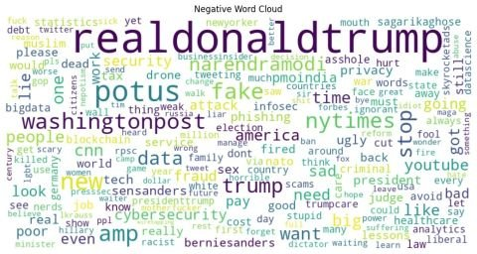  Top words: realdonaldtrump, potus,  washingtonpost, fake, data, security | 🟢 POSITIVE TWEETS  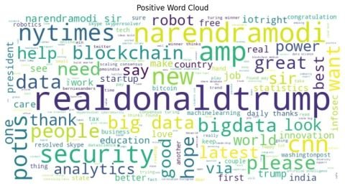  Top words: realdonaldtrump, narendramodi,  blockchain, bigdata, security, analytics

Conclusion: NLP sentiment analysis successfully separated positive and negative tweet patterns. The Word Cloud visualization confirmed clear thematic differences between the two sentiment classes.

— End of Q3 Assignment | Submitted by: Ammar —

